National Traffic Incident Management (TIM) Responder Training Program
TIM Responder Training Course Announcement

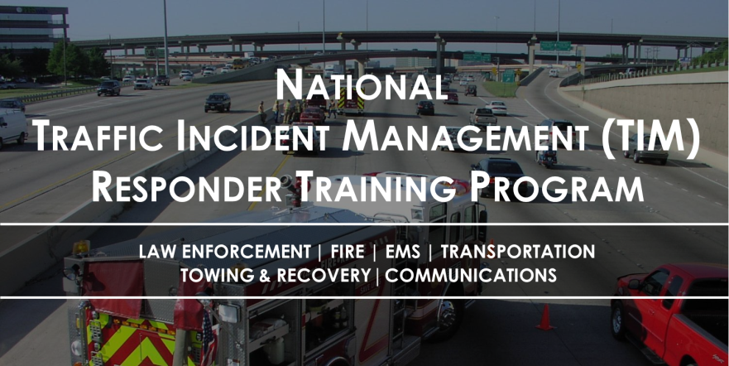
Why this is important… Responders are being struck and killed at traffic incidents in the U.S. on average:
- 5 Firefighters each year
- 1 Law Enforcement Officer each month
- 1 Tow Truck Operator each week
- Numerous transportation professionals each year from DOTs, Public Works, and Safety Service Patrols

The National TIM Responder Training Program was developed by responders for responders, and was designed to establish the foundation for and promote consistent training of all responders to achieve the three objectives of the TIM National Unified Goal (NUG):
- Responder Safety
- Safe, Quick Clearance
- Prompt, Reliable, Interoperable Communications
The target audience for the training is individuals from all TIM disciplines, including: Law Enforcement, Fire/Rescue, Emergency Medical Service, Towing and Recovery, Emergency Management, Communications, and Highway/Transportation.
TIM Responder Training Course Lesson Summary
- Introduction: definition of TIM and the dangers encountered when responding to incidents
- TIM Fundamentals and Terminology: safe, quick clearance goals and supporting legislation, and common response terminology
- Notification and Scene Size-Up: roles and responsibilities of public safety communications centers and transportation management centers, and scene size-up reporting
- Safe Vehicle Positioning: safe-positioning of vehicles, blocking, and safe practices for avoiding the zero buffer
- Scene Safety: emergency vehicle markings, emergency-vehicle lighting, and use of high-visibility safety apparel
- Command Responsibilities: high-level review of the Incident Command System (ICS)
- Traffic Management: components of a Traffic Incident Management Area, proper use of traffic control devices
- Special Circumstances: vehicle fires, hazardous materials, vehicle fluid spills, and crash investigations
- Clearance and Termination: quick clearance strategies, towing and recovery communications, and incident termination
Details for the upcoming TIM Responder Training course are as follows:
Date: March 29, 2016
Time: 0800-2100 hours
Location: Sikeston DPS
Address: 201 South Kingshighway, Sikeston, MO 63801
Registration Details: Julie Knodell 573-840-9500, Please Contact Julie for reservations.
This training has also been endorsed by the International Association of Chiefs of Police (IACP), the International Association of Fire Chiefs (IAFC), the American Association of State Highway and Transportation Officials (AASHTO), the National Volunteer Fire Council (NVFC), the International Association of Directors of Law Enforcement Standards and Training (IADLEST), and the Towing and Recovery Association of America (TRAA).

